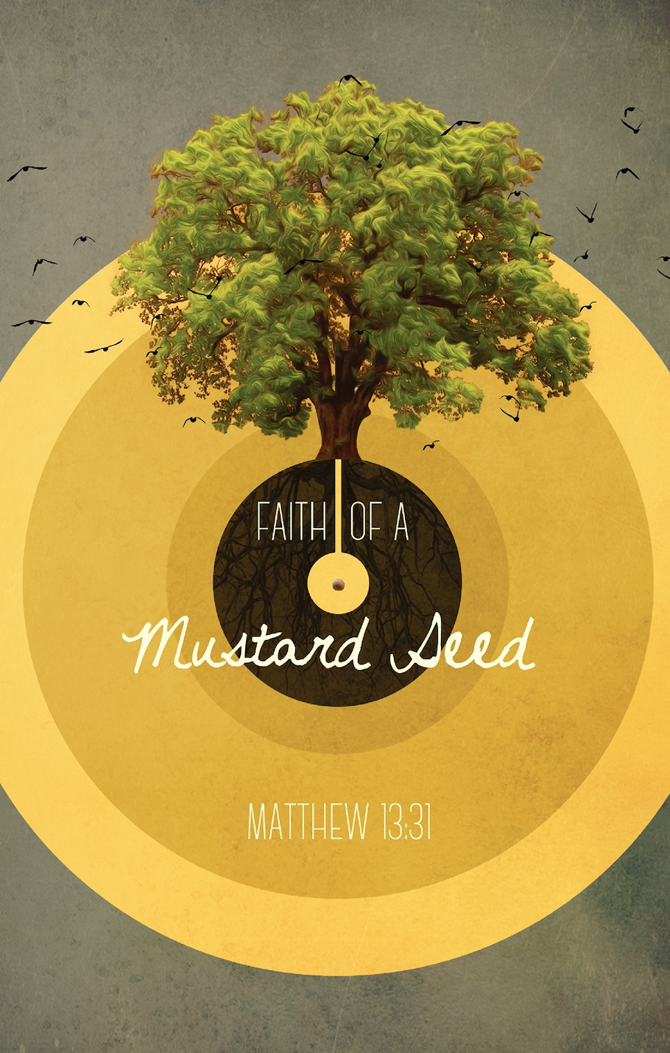
January 1st, 2023
HAPPY NEW YEAR!

What might we be able to accomplish this new year for the kingdom of God?
- ___ can do _____l things through _________ who strengthens ____. (Philippians 4:13)

We have taken time to build up our confidence after many attempts by Satan to destroy it!
-And he will try again so always be watching!

Our new focus for 2023 is “_________ of a ____________ seed.”

Our new focus is geared to take our confidence in God to the next level.

Jesus teaches the value of a grounded and lively faith. A faith that is visible and active every day. James teaches us that if we say we have faith but are not active in it, our faith is actually dead!
“So also faith by ________, if it does not have ___________, is dead.” (James 2:17)

_______________________- Is an example of someone of “little faith”

_______________________- Is an example of someone who had “great faith”

As we work diligently to let our faith develop like the mustard seed in Matthew 13 we will take hold of new opportunities to serve God and one another.

By developing our faith in God we will be pleasing to Him.

- We will be more zealous to tell others about His Word & His Son

- We will have a greater focus on growing closer together as a family

- We will find a strength that will weather the most difficult trials this life has to offer

May the Lord work mightily in your life this year! May He bless all of us here at Laurel Canyon as we work together!

