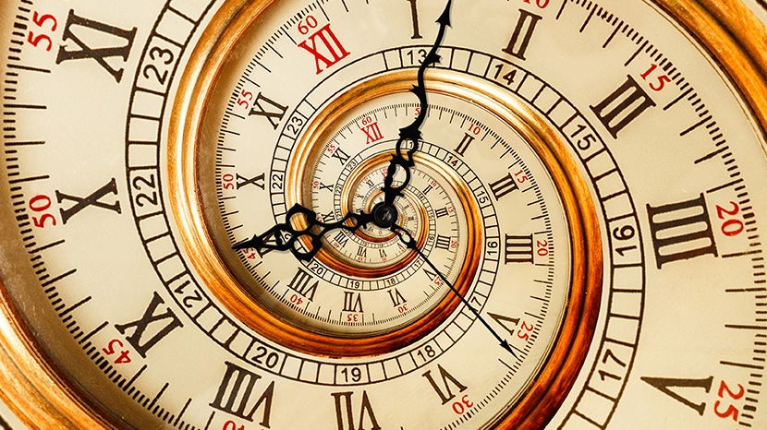
REDEEMING THE TIME NOVEMBER 06, 2022

Source text: Ephesians 5:15-21, Colossians 4:2-6 & John 9:4

Ecclesiastes 3:1 “For everything there is a ________________, and a _________ for ___________ matter under heaven.”

Solomon said there was a time for many things!

A time to be _____________
A time to _____________
A time to _____________
A time to _____________
A time to _____________
A time to _____________
A time to _____________
A time to _____________
A time to _____________
A time to _____________
A time to _____________
A time to _____________
A time to _____________
A time to _____________
A time to _____________
A time to _____________
A time to _____________
A time to _____________
A time to _____________
A time to _____________
A time to _____________
A time to _____________
A time to _____________
A time to _____________
A time to _____________
A time to _____________
A time to _____________
A time to _____________

That is a lot of time!

Ephesians 5:15-21 / ESV
Look carefully then how you ________, not as __________ but as _________, making the best use of the _________, because the days are _________. Therefore do not be _____________, but understand what the will of the ________ is. And do not get drunk with wine, for that is debauchery, but be filled with the _________, addressing one another in psalms and hymns and spiritual songs, singing and making melody to the Lord with your _________, giving _____ ___________ and for _______________ to ______ the Father in the name of our Lord Jesus Christ, ______________ to ______ ______________ out of reverence for _________.

“The time is fulfilled, and the kingdom of God is at hand; repent and believe in the gospel.”
Mark 1:15

Closing Thought:
Besides this you know the time, that the hour has come for you to wake from sleep.
For salvation is nearer to us now than when we first believed. -Romans 13:11

